**Michael Christopher – s224830467**

**CAPRI - Correlation of Air Pollution and Respiratory Illness**

*What have been done?*

1. **Onboarded Two New Team Members:**

We briefed the new members on the project scope, Agile workflow, and our research direction.

So what? This ensures alignment within the team and distributes responsibilities more effectively, improving productivity and collaboration from this point forward.



1. **Held a Brainstorming Session with Full Team:**

Conducted a second brainstorming session, incorporating fresh perspectives from the new members. One proposed integrating an API to collect real-time AQI, and another initiated prototyping a browser-based interface using HTML/CSS.

So what? These contributions enhance the technical feasibility and interactivity of our project, potentially increasing its real-world applicability.

1. **Continued Dataset Research and Curation**

Maintained momentum in identifying viable datasets, placing geospatial analysis temporarily on hold to focus on foundational data gathering and preprocessing.

So what? Clean and relevant data are prerequisites for valid analysis. Prioritising this ensures that downstream modelling will be meaningful and ethical.

1. **Curated a Resource and Inspiration Repository**

Finalised a list of key data sources and project inspirations, including:

* *IQAir Website for Inspiration -*<https://www.iqair.com/au/australia?srsltid=AfmBOorWtsas_MkP8jOKCi0y2rmyHVPll9jYE6W5q6TQXdAD_O_Zd81Y>
* *Kaggle Air Quality Prediction Inspiration -* <https://www.kaggle.com/code/hamedetezadi/air-quality-prediction>
* *AU Gov Data -* <https://www.data.gov.au/data/dataset?q=Air+quality&organization=state-of-the-environment&ext_bbox=&ext_bbox_lga=>
* *\*\* EPA Air Watch Hourly AQI Dataset -* <https://discover.data.vic.gov.au/dataset/epa-air-watch-all-sites-air-quality-hourly-averages-yearly>
* *\*\* Australia Air Quality, State of the Environment Book -* <https://soe.dcceew.gov.au/sites/default/files/2022-07/soe2021-air-quality.pdf>
* *AU Bureau of Statistics -* [*https://www.abs.gov.au/statistics/measuring-what-*matters/measuring-what-matters-themes-and-indicators/sustainable/air-quality#data-downloads](https://www.abs.gov.au/statistics/measuring-what-matters/measuring-what-matters-themes-and-indicators/sustainable/air-quality#data-downloads)

** - Crucial Resources

So what? These resources shape the scope and methodology of our analysis. They serve both as technical references and baselines for comparative modelling.

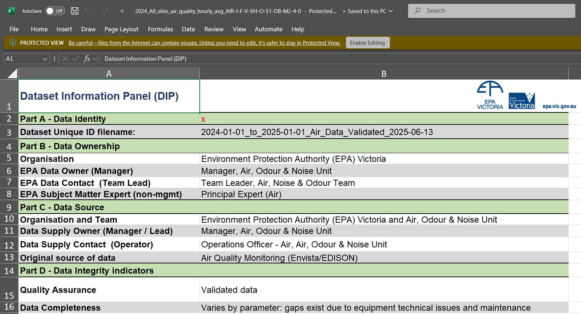

Excel file from [EPA Air Watch All Sites Air Quality Hourly Averages - Yearly - Dataset - Victorian Government Data Directory](https://discover.data.vic.gov.au/dataset/epa-air-watch-all-sites-air-quality-hourly-averages-yearly)

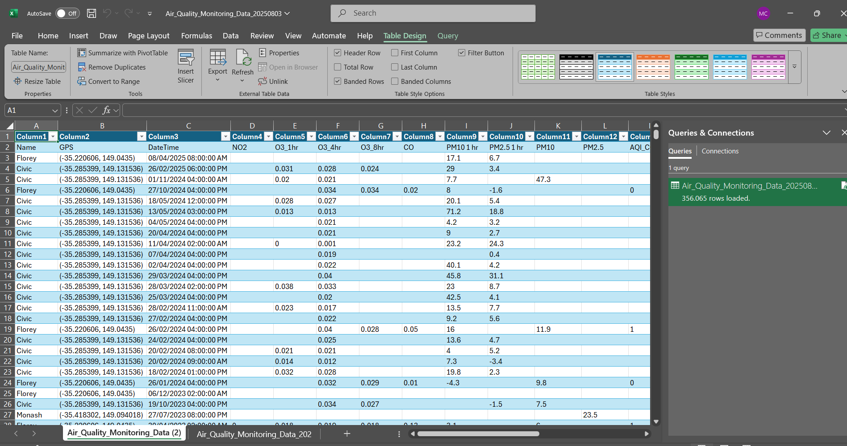

CSV file from [Air Quality Monitoring Data | Open Data Portal](https://www.data.act.gov.au/Environment/Air-Quality-Monitoring-Data/94a5-zqnn/about_data) for ACT state

Excel file from [Data download facility | Air Quality NSW](https://www.airquality.nsw.gov.au/air-quality-data-services/data-download-facility)

File from [Download air data | Environment, land and water | Queensland Government](https://apps.des.qld.gov.au/air-quality/download/)

And other data from other states.

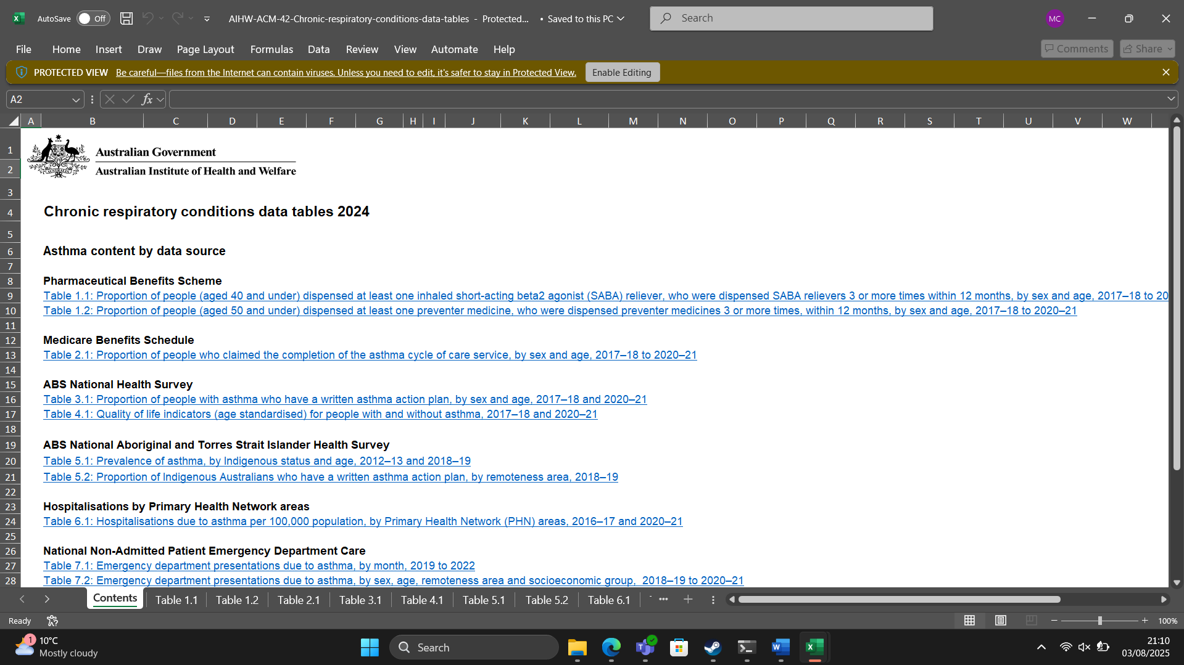

Excel file from [Chronic respiratory conditions Data - Australian Institute of Health and Welfare](https://www.aihw.gov.au/reports-data/health-conditions-disability-deaths/chronic-respiratory-conditions/data)

1. **Update Agile Project Planner:**

Revised the shared team planner to reflect new team roles, current priorities, and iterative milestones.

So what? This ensures transparency, accountability, and efficient sprint execution as our project’s scales.

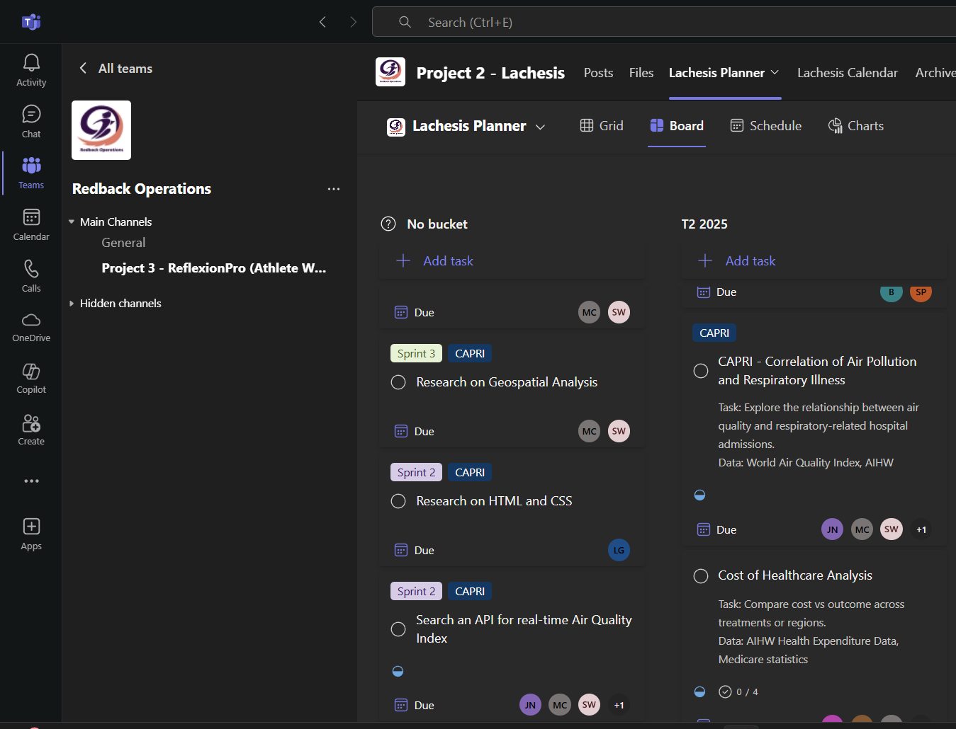

*Next actions?*

1. **Begin Dataset Cleaning and Integration**

Initiate preprocessing pipelines to clean and merge AQI and health data (starting with EPA and AIHW datasets).

Why? High-quality inputs are critical for statistical analysis and model validity. This is a necessary precursor to any predictive or correlational insights.

1. **Explore and Evaluate AQI APIs**

List potential real-time AQI APIs and assess their integration viability in a prototype environment.

Why? This will support dynamic and user-facing features, enhancing the project's interactivity and value.

1. **Draft Initial Visualisation Concepts**

Develop early mock-ups or low-fidelity prototypes for data visualisations (e.g., temporal charts, pollution trends).

Why? Early visual feedback can reveal gaps in data or storytelling, allowing for adjustments before full implementation.

1. **Revisit Geospatial Analysis Roadmap**

After foundational data work, revisit tools (e.g., Folium, GeoPandas) for mapping and regional comparisons.

Why? Spatial insights are central to linking air quality and health outcomes geographically, which is the project's core aim.